# PROJECT Report

# Bags project-BAG EMPORIUM

Submitted by :

Harshdeep singh

G5 201099080

This project is based on E-commerce website i.e. Online Bags Store through which customers can order wide range of products present worldwide.The website is divided into different sections and categories for the ease of customers so that they can order different items according to their needs at reasonable price.The benefit of ordering from our online store is that the customer can order their favourite items from the comfort of their home that too at lower prices.

OUR LOGO



# HOME PAGE

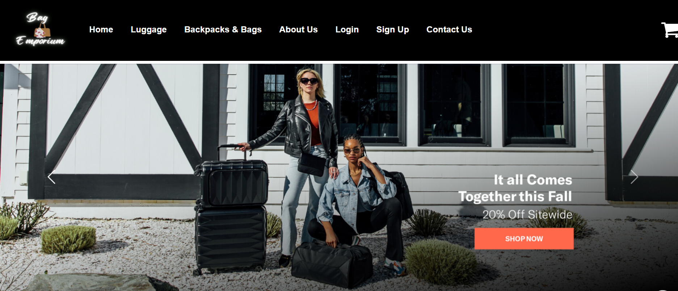

**The Home Page Contains The Navigation Bar Which Consists Of Different Components That Allows Our Customers To Navigate Conveniently Between Different Sections Of The Website.The Navigation Bar Consists Of Home Page,Luggage Page, Backpacks & Bags Page,About Us Page,Login Page,Sign Up Page And Contact Us Page.The Navigation Bar Has Been Created Using Bootstrap 5.Bootstrap Allows Us To Make Responsive Web Pages Conveniently Using Already Defined Themes And Codes. Navbars Require a Wrapping .Navbar With .Navbar-Expand{-SM|-MD|-LG|-XL|-XXL} For Responsive Collapsing AND [Color Scheme](https://getbootstrap.com/docs/5.2/components/navbar/" \l "color-schemes) Classes.**

**CAROUSEL:The Carousel Is a Slideshow For Cycling Through a Series Of Content, Built With Css 3d Transforms And a Bit Of Javascript. It Works With a Series Of Images, Text, Or Custom Markup. It Also Includes Support For Previous/Next Controls And Indicators.**



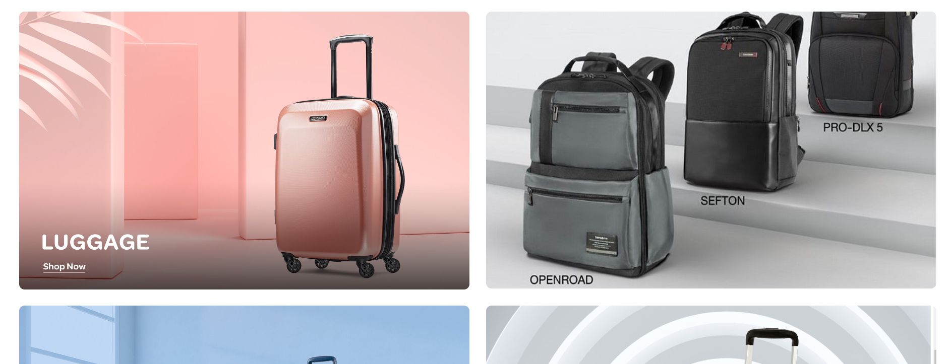

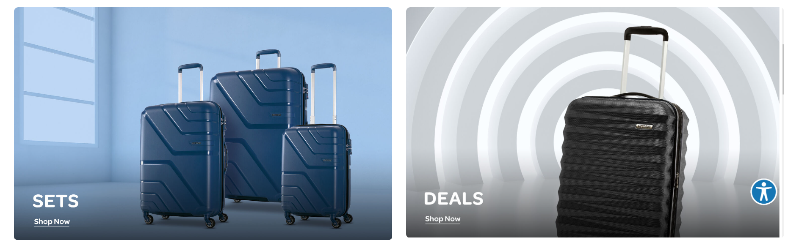

**The Home page further contains the Categories section which consists of different categories of products that allows the user to order conveniently according to their needs.This section has been made using bootstrap components such as CSS GRID.Bootstrap’s default grid system represents the culmination of over a decade of CSS layout techniques, tried and tested by millions of people. But, it was also created without many of the modern CSS features and techniques we’re seeing in browsers like the new CSS Grid.**

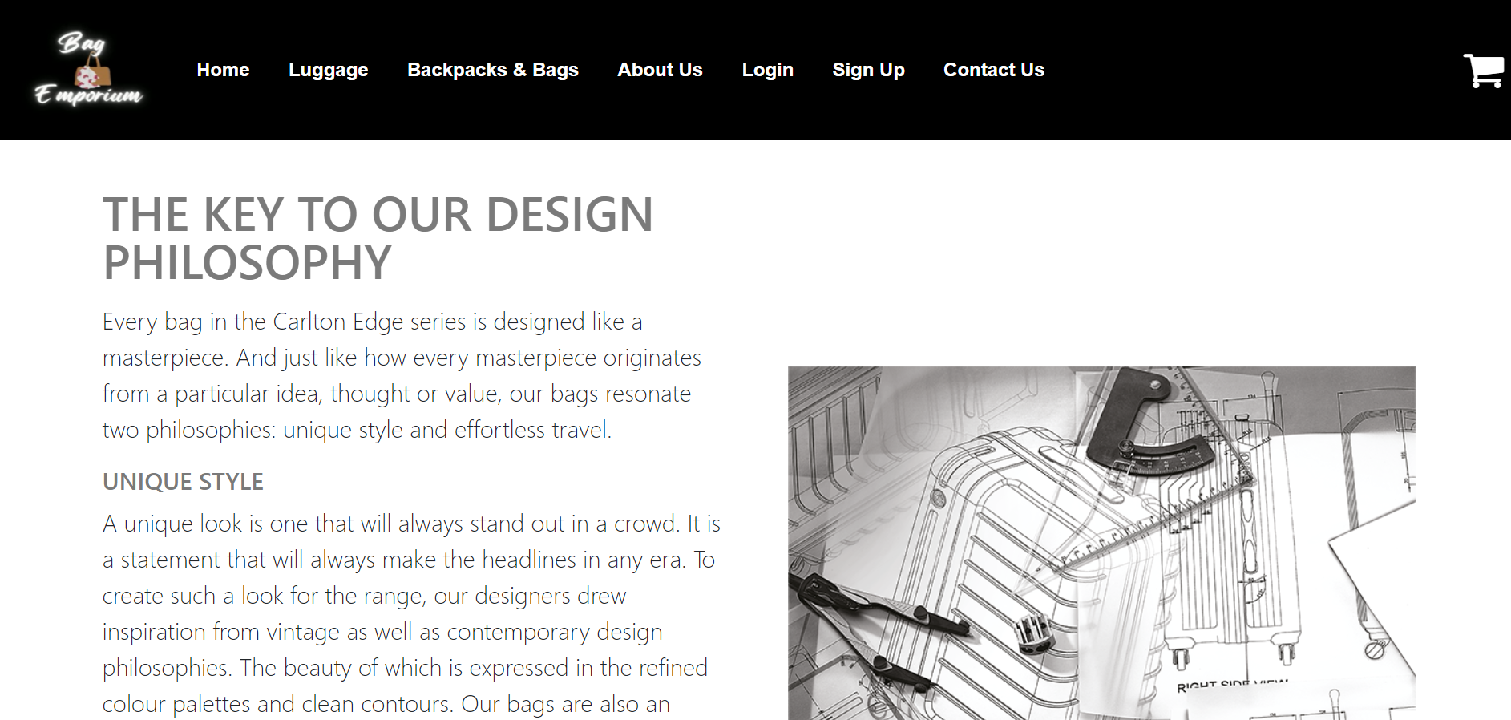

**This section represents our style of designing and the philosophy behind it.It has been created using bootstrap containers**

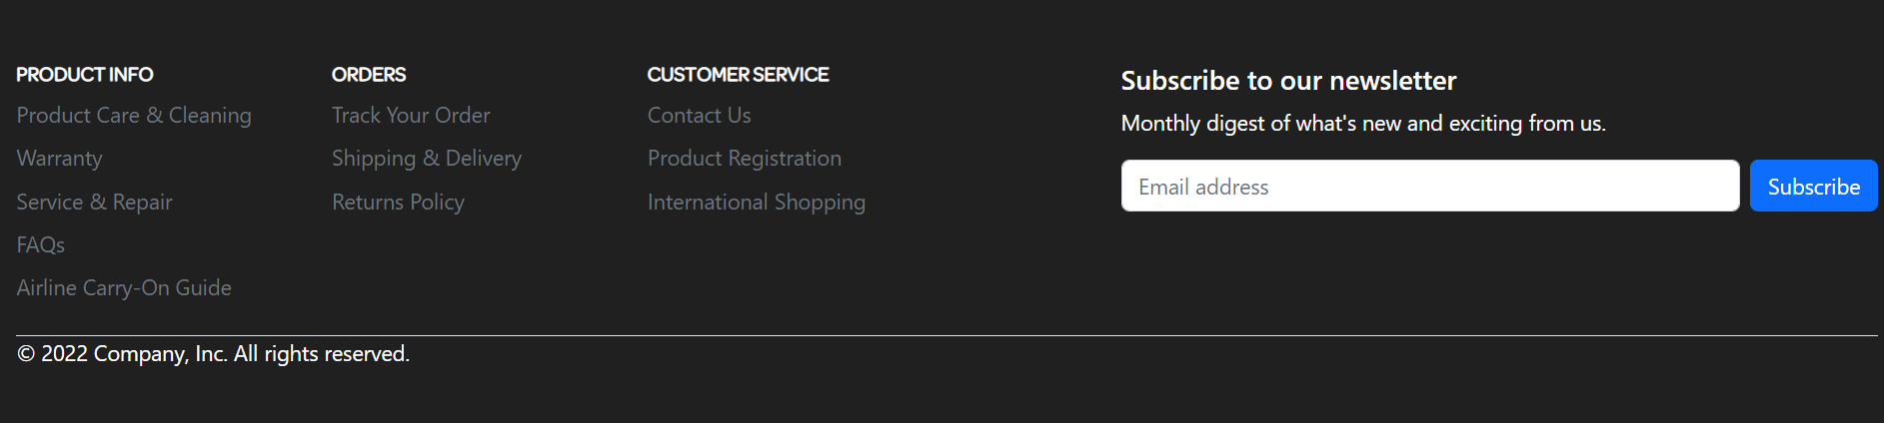

**This is the Footer section of the home page.It contains all the necessary links related to Product Info,Orders,Customer Service,etc.This has been created using footer template of bootstrap...**

# LUGGAGE PAGE

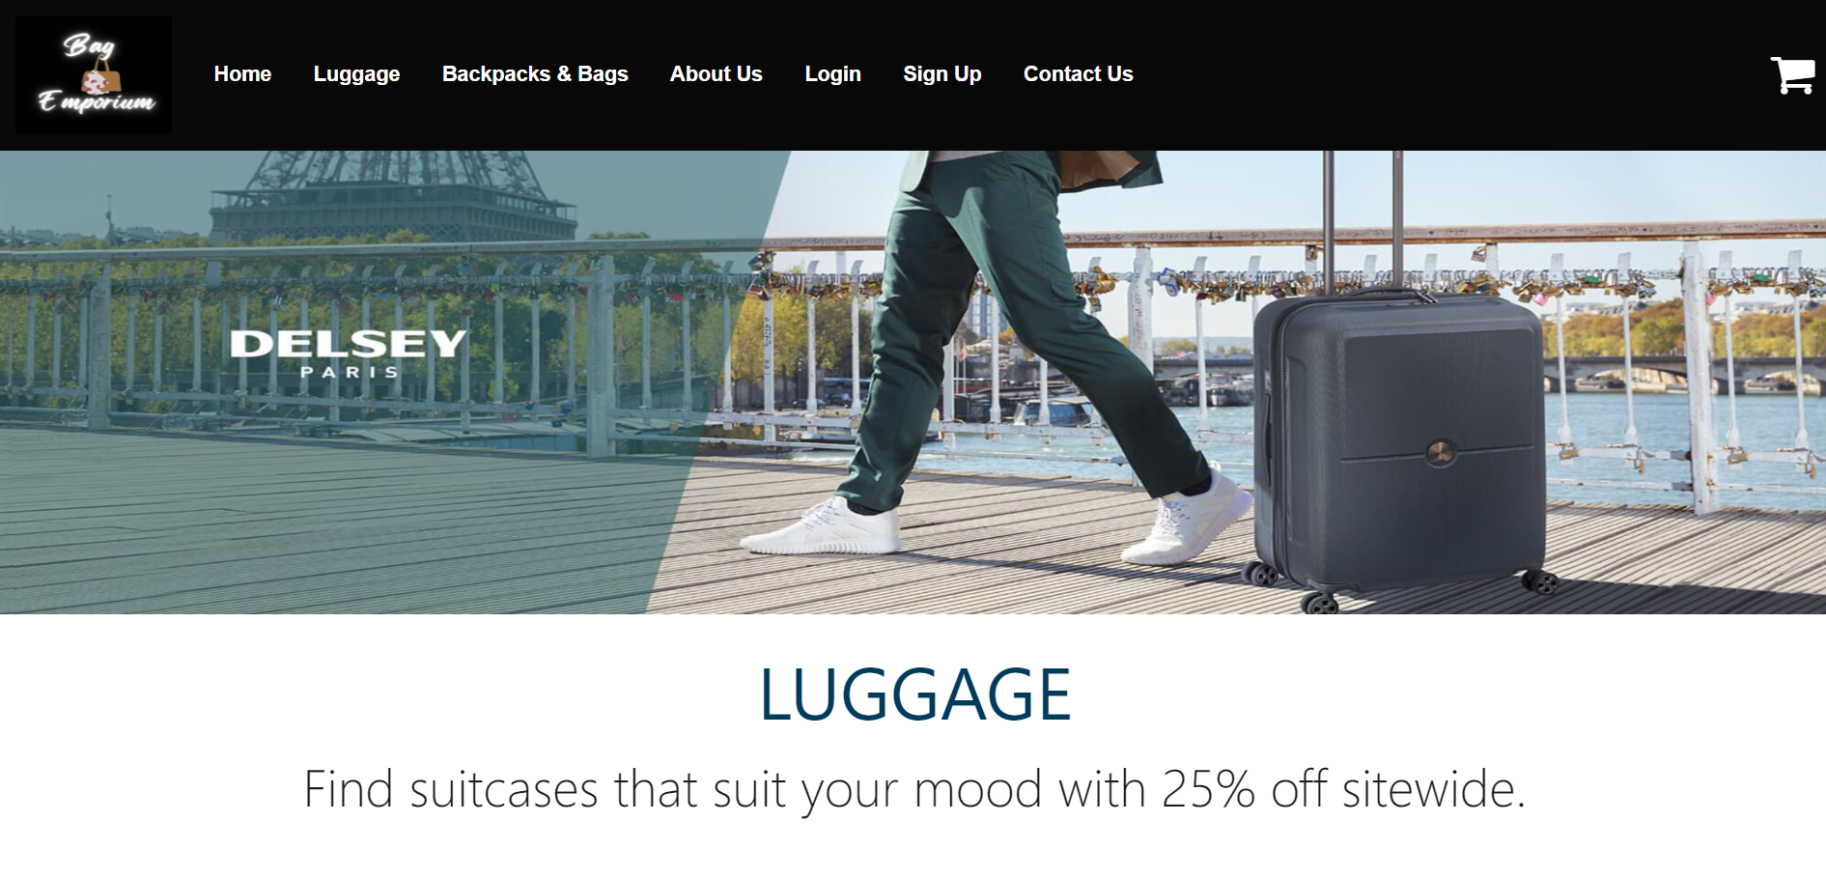

**This page consists of wide range of travel bags at reasonable prices with over 25% off.**

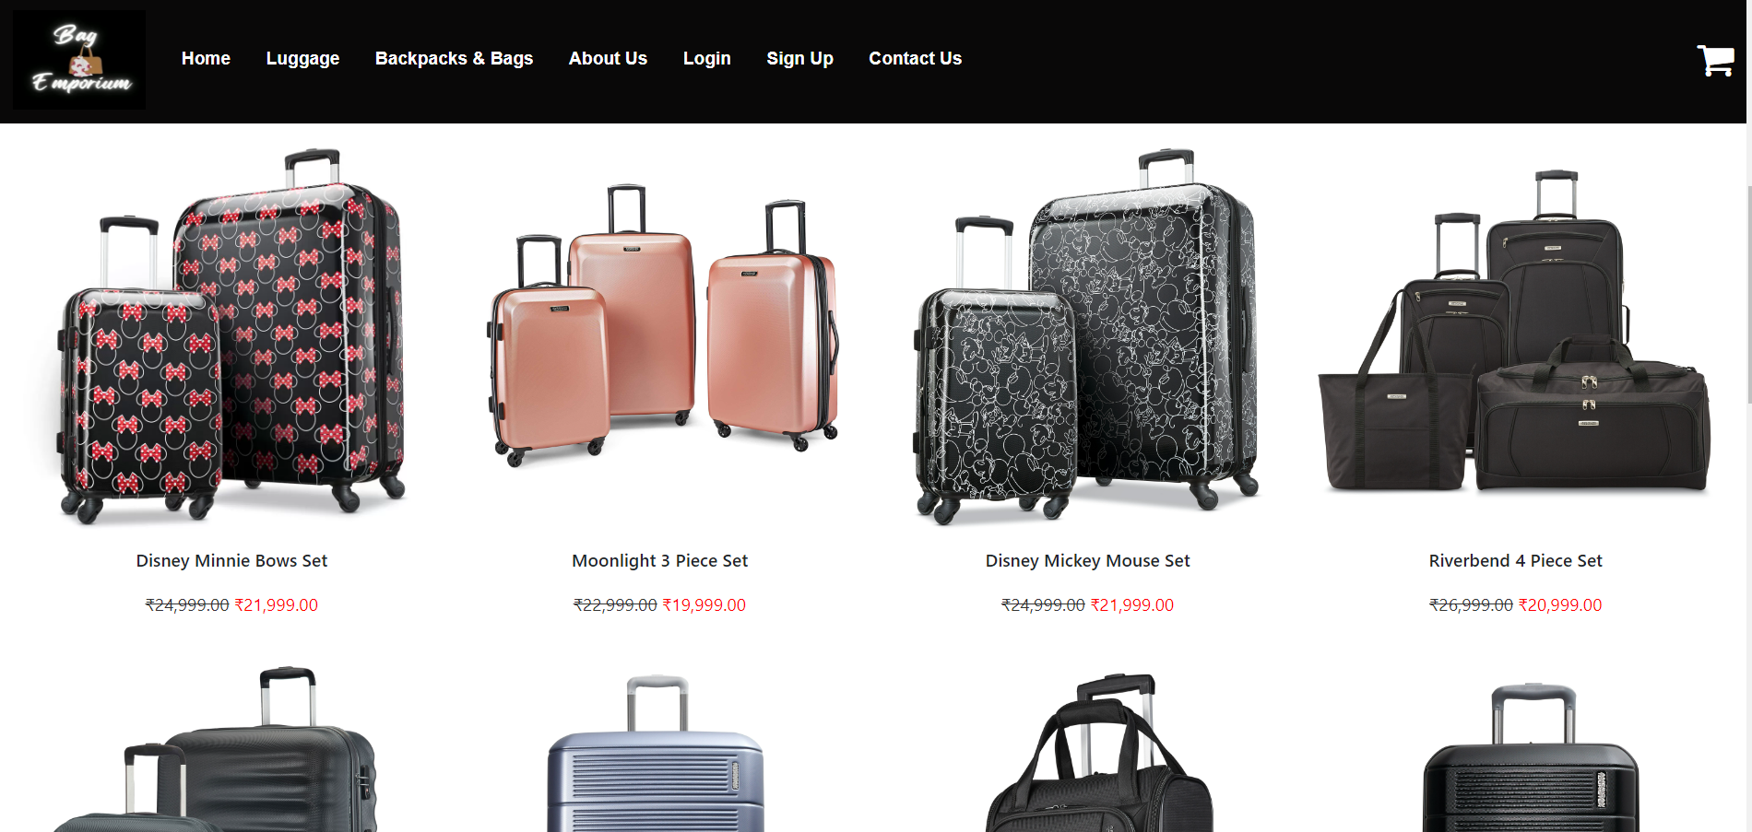

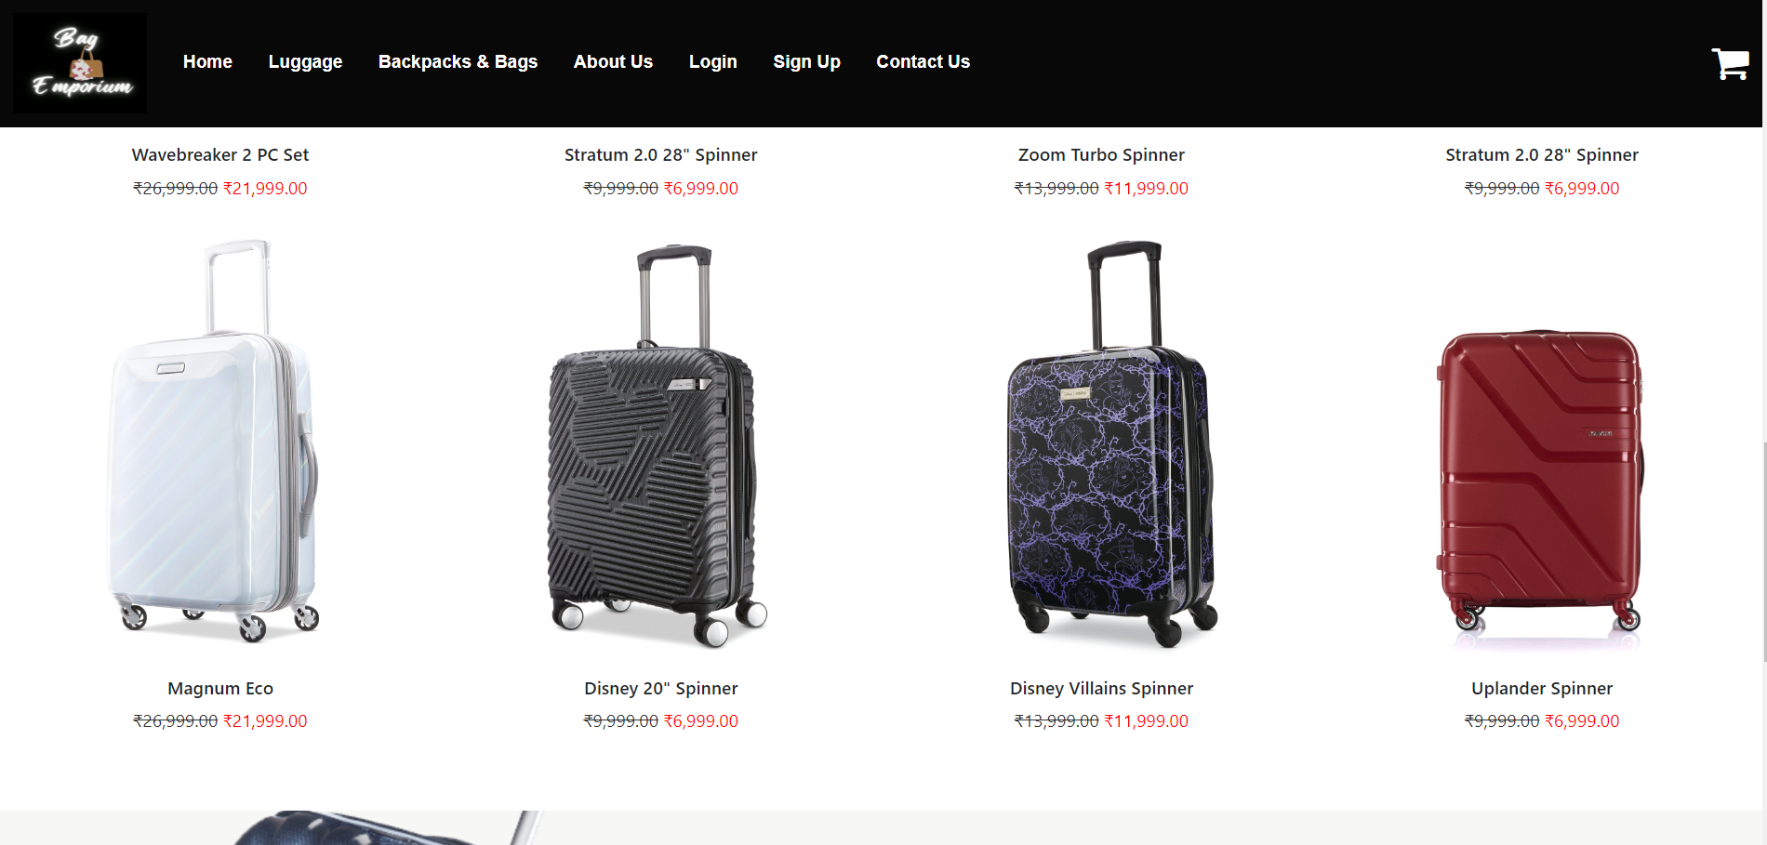

**The luggage page has been designed using the grid system of bootstrap that allows us to align various components systematically.It contains numerous luggage bags allowing our customers to order from a variety of products.**

**GRID SYSTEM**

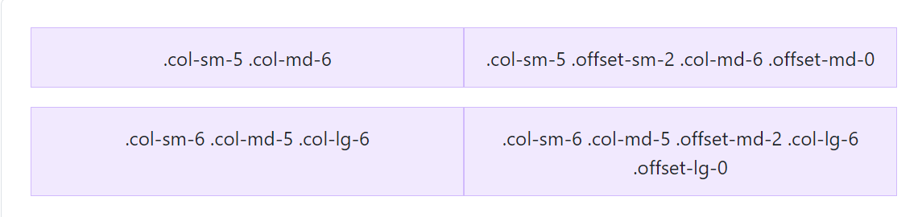

# BACKPACKS & BAGS PAGE

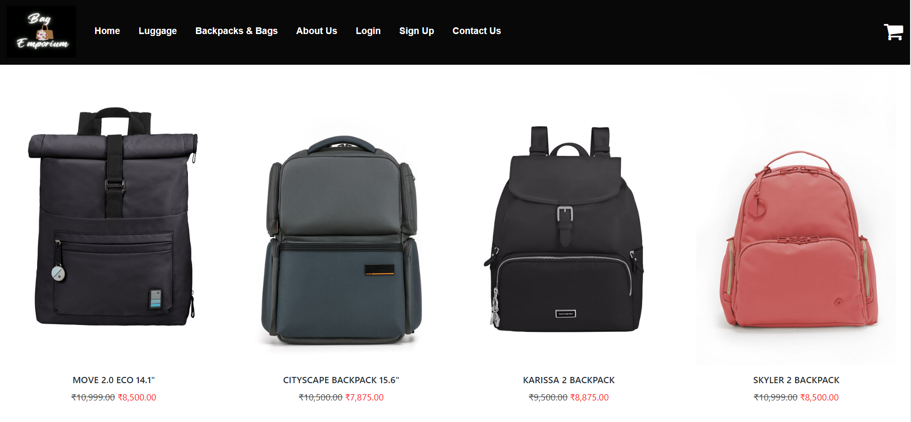

**This sections contains different types of backpacks according to the needs of our customers.The different product images have been aligned using grid system of bootstrap along with the text.The grid system makes it easy for the coder to arrange all the elements simultaneously without any hassle.**

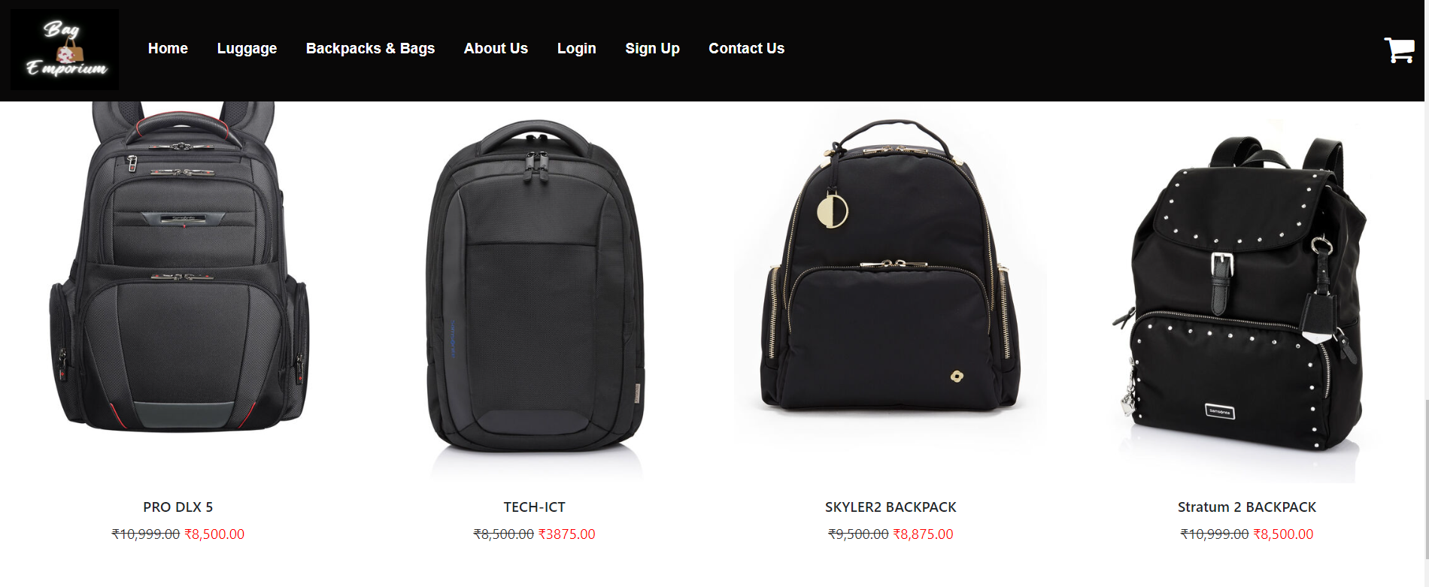

ABOUT US PAGE

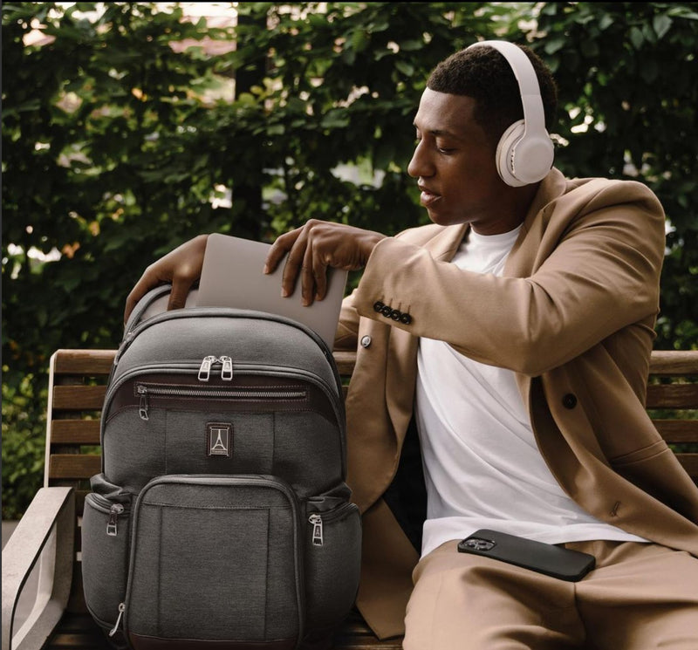

# Bag Emporium - Pack More Fun!

At Bag Emporium, we believe travel should be fun. We take pride in making stylish, high quality, and yeah, fun luggage that you can rely on. In 1933 Sol Koffler put his life savings on the line to start a luggage company in Providence, Rhode Island. His dream was to build a tough suitcase that could sell for a dollar - Bag Emporium was born.

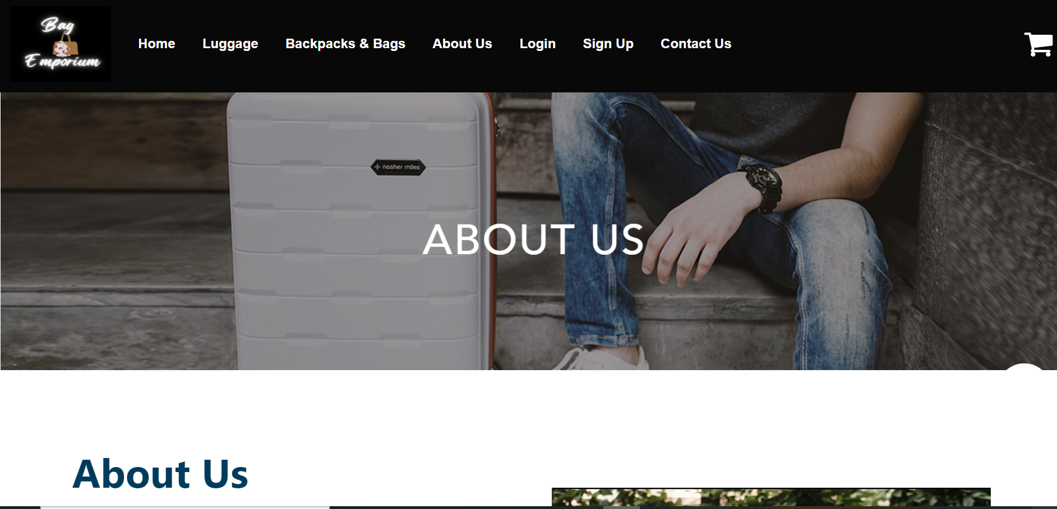

**The About us section tells our customers about our journey and our future vision for them.Bag Emporium is the smart choice for you and your family, offering a wide selection of travel products including luggage items as well as casual, and business bags. We understand how you travel, so we're ready to go when you are with the gear that's right for you!**

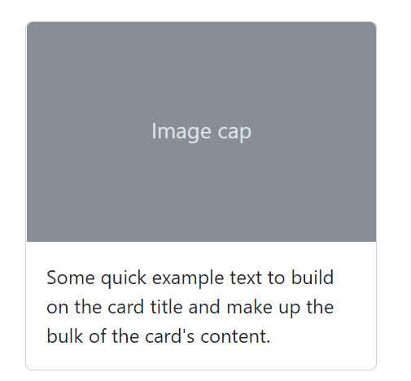**Th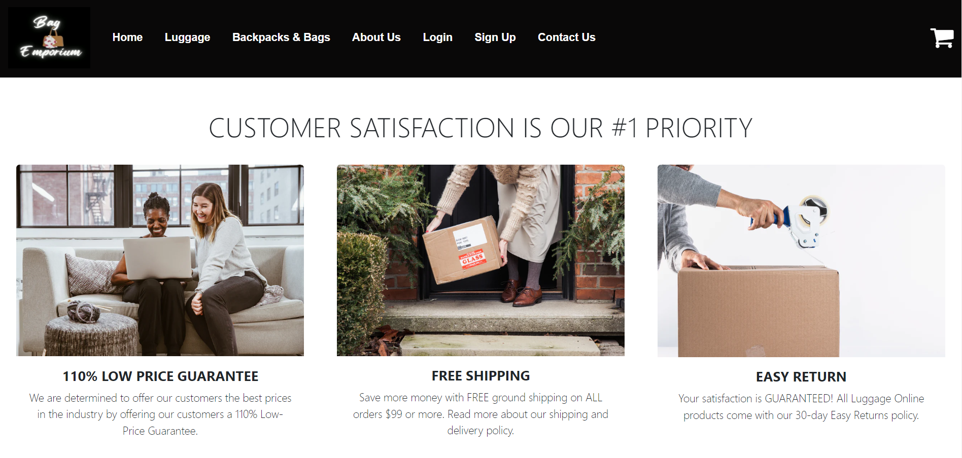is section represents our vision for our customers.**

**1)110% Low Price Guarantee**

1. **Free Shipping**
2. **Easy Return**

**It has been created using card and caption theme of bootstrap.**

**.card-img-top places an image to the top of the card. With .card-text, text can be added to the card. Text within .card-text can also be styled with the standard HTML tags.**

LOGIN PAGE

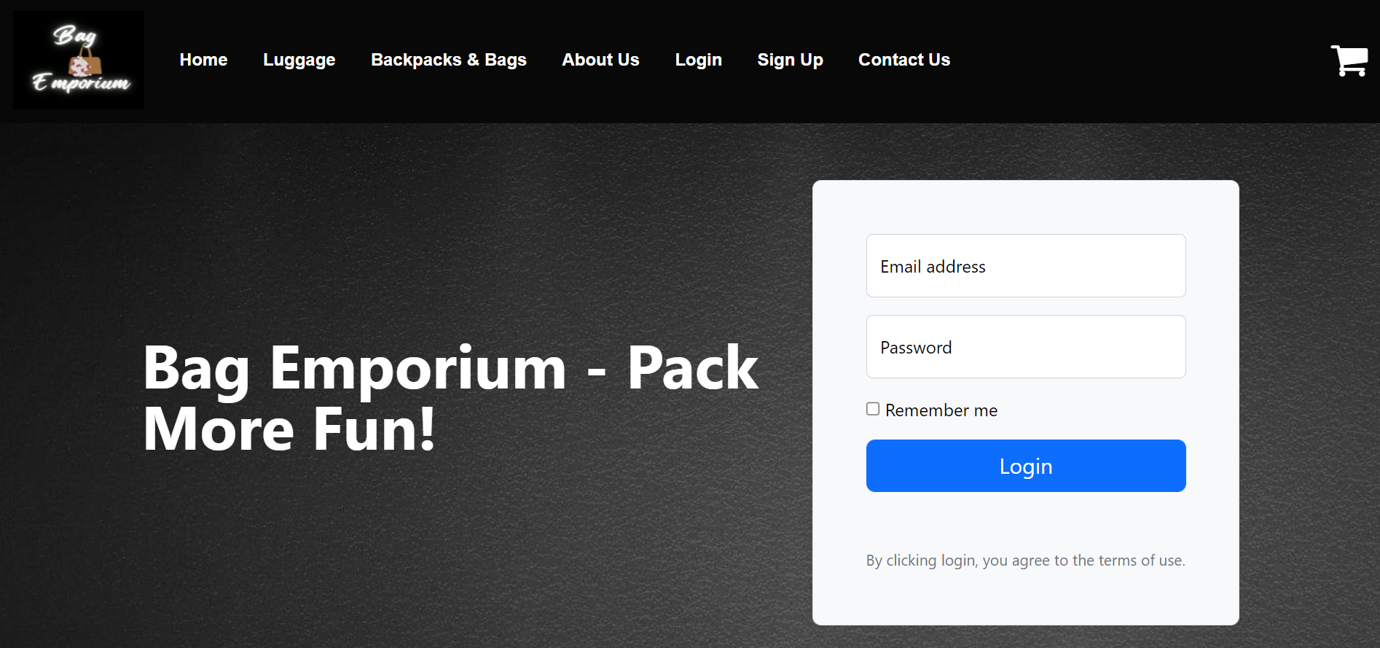

**This page contains log in section for our customers so that they can access their orders easily and track their shipments.It has been implemented using the bootstrap login theme.**

SIGN-UP PAGE

**This Page Lets The User To Create Their Account On Our Site So That They Can Access Their Orders Easily And Track Their Shipments And Receive Special Offers Before Time.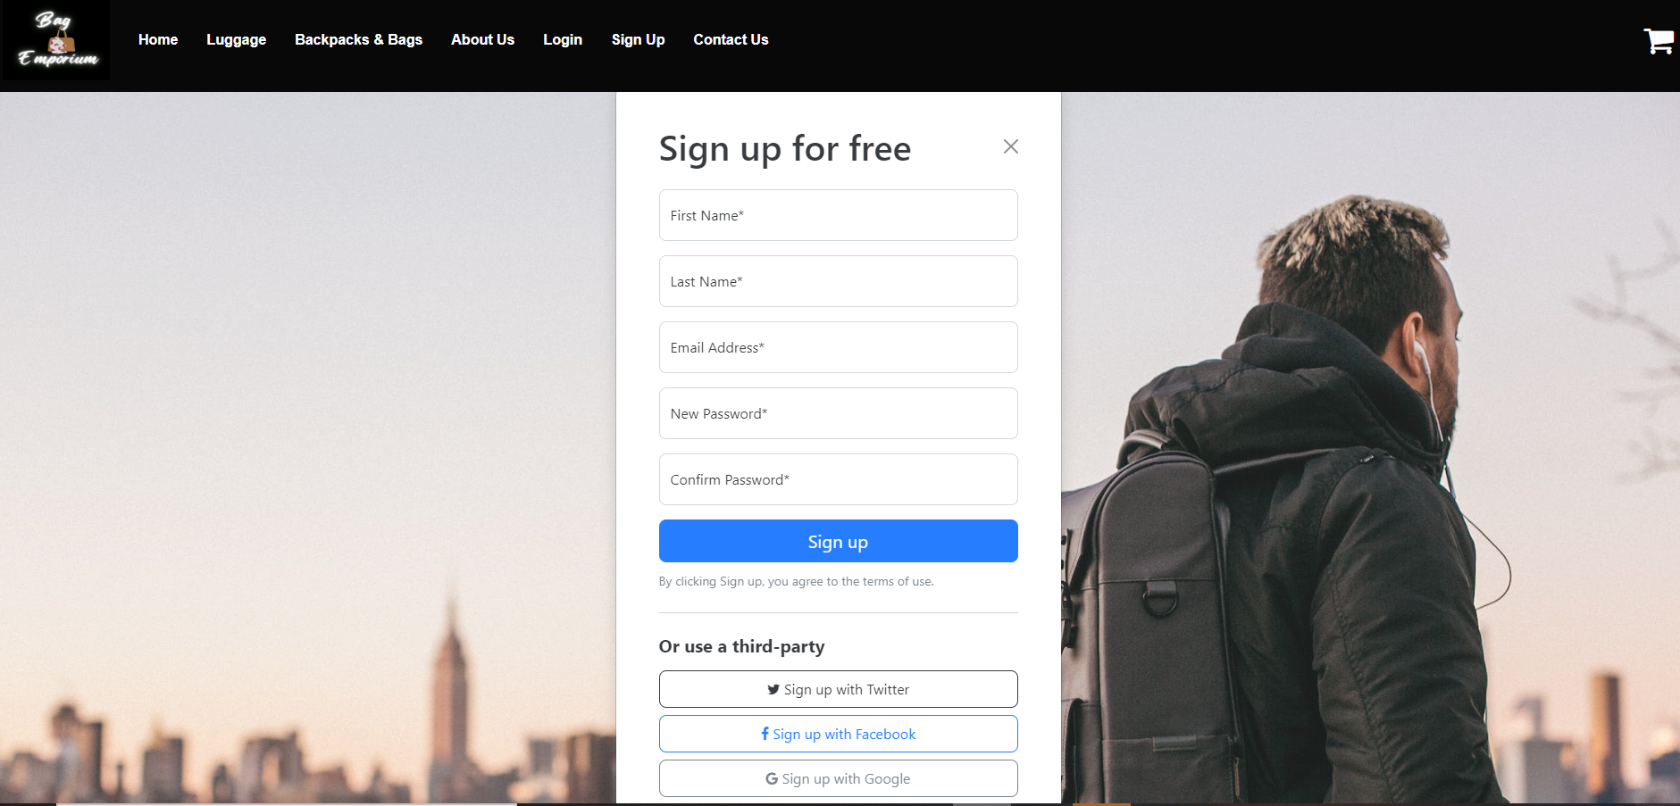Customers can also sign up using Twitter,Facebook,Google securely and enjoy our benefits.**

CONTACT US PAGE

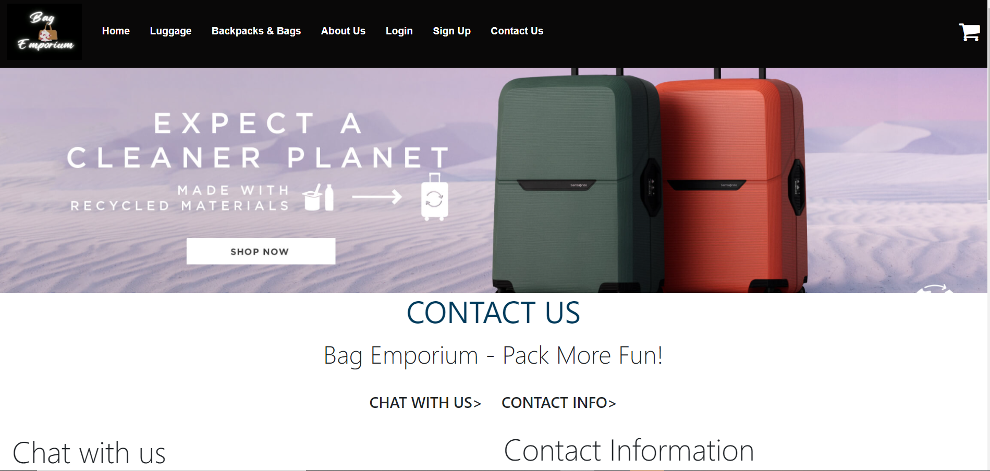

**The Contact page allows the customers to stay in touch with us 24/7**

**allowing us to provide our services as soon as possible.**

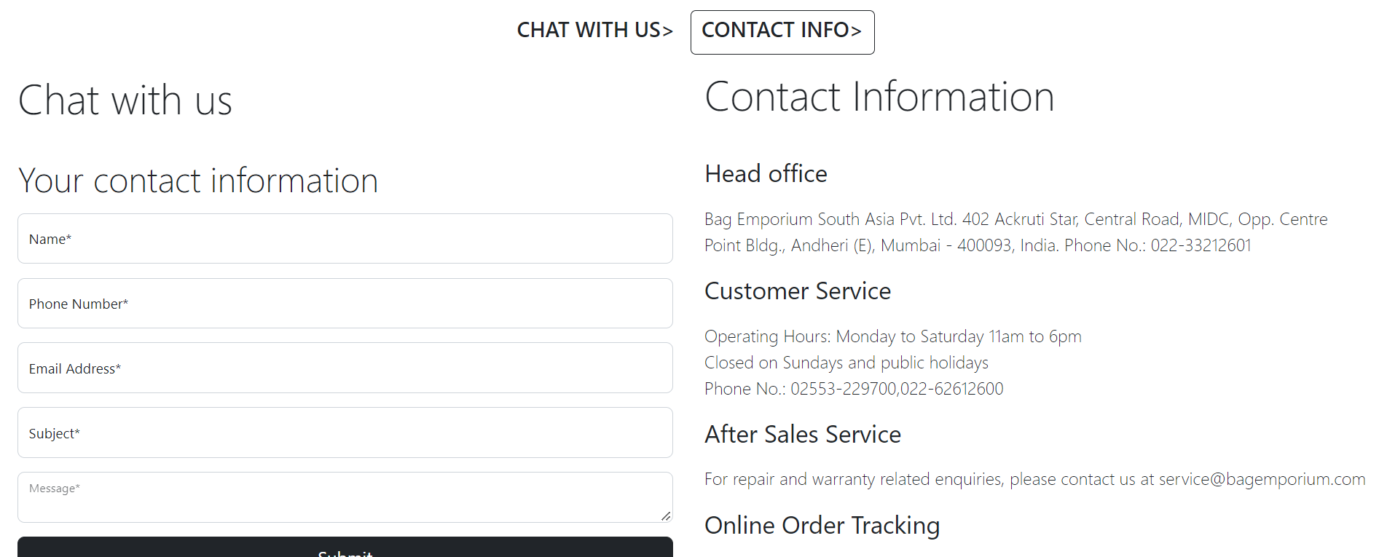

**This section has been created using bootstrap COLLAPSE component.The collapse JavaScript plugin is used to show and hide content. Buttons or anchors are used as triggers that are mapped to specific elements you toggle. Collapsing an element will animate the height from its current value to 0.**

